Queston 1

1.1

**Agile Approach to Development**

The agile approach methodology is an approach which is incremental and iterative to emphasize flexibility, collaboration, and customer satisfaction when developing a new software. In this report, will be discussing the key features of the agile approach, how the agile approach will impact the airport project management approach, and whether or not this approach will be suitable for the development of the Airport Customer Relationship Management System.

**Key features of the Agile development approach**

* **Iterative development**: the agile approach allows the software development lifecycle (SDLC) to be broken down into smaller units which enables developers to create, test, analyze, and refine ideas timeously during the design process which allows the process to be more time and cost effective. In terms of the airport management system, this means that features such as navigation tools, emergency services, etc, can be developed and implemented incrementally.(Awati, 2023) (Indeed, 2023)
* **Customer Inclusion:** the agile approach aims to collaborate with the company’s stakeholders such as staff members, management, and customers in order to prioritize customer satisfaction. This will benefit the airport management system as it will be able to accommodate the constantly evolving needs of customers and the indecisive executive.(Brush, 2022)
* **Adaptability:** the agile approach encourages system flexibility and change which is a compulsory requirement for the airport management system as it will be able to accommodate the changing requirements and needs of the airport as well as last minute changes from stakeholders. this will allow the system to be developed early.(Brush, 2022)
* **Continuous development and improvement:** The agile approach focuses on continuously developing and improving the system by correcting flaws and enhancing features. This is crucial for the airport management system as the aim is to provide a satisfactory customer experience.(Indeed, 2023)

**Impact the Agile development approach will impact the project management solution**

* **Iterative delivery:** the agile approach will impact the project management solution by involving the process of iterative planning in the system development project. This means that the development process will now be broken down into sub-units which can be developed, tested, analysed, and deployed individually allowing the system to be changed easily to satisfy the indecisive executive.(Billah, 2024)
* **Shared decision making:** the agile approach promotes collaborative decision making amongst stakeholders which allows designers to understand the system requirements better as all parties’ expectations will be aligned.(Billah, 2024)
* **Work on continuous improvement:** agile development approach focuses on continuous development and improvement of the system which allows the system to adapt and be more flexible to accommodate the airports changing environment. This is helpful in ensuring that the customers expectations are always met.(Anon, 2024)

**Why the Agile approach will be suitable for developing the Airport Customer Relationship Management System.**

The agile development approach will be beneficial to the Airport Customer Relationship Management System as it will make the system adapt to change better which will satisfy the needs to the indecisive executive and deliver the system earlier than anticipated(Anon, 2023). This will also promote flexibility in the system which will address the user’s changing expectations. The agile approach also focuses more on customer collaboration which involves all the stakeholders involved in the airport management system. This will ensure that the goals of all the stakeholders are aligned with each other which makes the system more satisfactory(Lynn, 2023). The agile development system aids risk mitigation in the systems as it promotes frequent feedback to the developers which results in the continuous improvement of the system and therefore mitigating risk. (Lynn, 2023)

1.2

**System Vision Document: Airport Customer Relationship Management System.(Yalovenko, 2023)**

**Introduction:**

The Airport Customer Relationship Management System is a system designed to offer information, navigation, and medical information to airport customers and to satisfy stakeholders expectations.(Indeed, 2023)

**Purpose:**

The purpose of the system is to provide customers with an excellent customer experience by providing real-time flight updates, navigation around the airport, and provide medical assistance.(Indeed, 2023)

**Objective:**

The objective of this system is to deliver “top-class” customer service by providing real-time updates to customers and passengers and increase the safety of the passengers by ensuring that they have quick and easy access to medical assistance.

**Scope:**

The system will allow the passengers to gain access to key information such as flight details, amenities, navigation, and medical information.

**Stakeholders:**

Stakeholders include: (Fernando, 2024)

* Airport Management
* Passengers
* Customers
* Staff members
* Medical service providers

Question 2

2.1

(From assignment document, 2024)

**Flight information:** the system will provide real-time updates to passengers regarding flight information such as departure time, flight number, boarding gates, etc.

**Navigation updates:** the system will offer navigation around the airport using an inbuilt GPS to help passengers navigate their way through the airport.

**Instant medical attention:** the system will allow passengers to request instant medical attention in case of emergencies.

2.2

**System usability:** the system will need to be user-friendly and easy to use and navigate through.(Sharma, 2022)

**System availability:** the system will need to be always readily available to assist passengers at any time with minimal downtime.(Sharma, 2022)

@using Microsoft.AspNetCore.Identity

<ul class="navbar-nav">

@if (SignInManager.IsSignedIn(User))

{

<li class="nav-item">

<**a** id="manage" class="nav-link text-dark" **asp-area**="Identity" **asp-page**="/Account/Manage/Index" title="Manage">Hello @UserManager.GetUserName(User)!</**a**>

</li>

<li class="nav-item">

<**form** id="logoutForm" class="form-inline" **asp-area**="Identity" **asp-page**="/Account/Logout" **asp-route-returnUrl**="@Url.Action("Index", "Home", new { area = "" })">

<button id="logout" type="submit" class="nav-link btn btn-link text-dark border-0">Logout</button>

</**form**>

</li>

}

else

{

<li class="nav-item">

<**a** class="nav-link text-dark" id="register" **asp-area**="Identity" **asp-page**="/Account/Register">Register</**a**>

</li>

<li class="nav-item">

<**a** class="nav-link text-dark" id="login" **asp-area**="Identity" **asp-page**="/Account/Login">Login</**a**>

</li>

}

</ul>

Question 3

3.1 **Airport passenger ERD** [**https://app.diagrams.net/**](https://app.diagrams.net/)

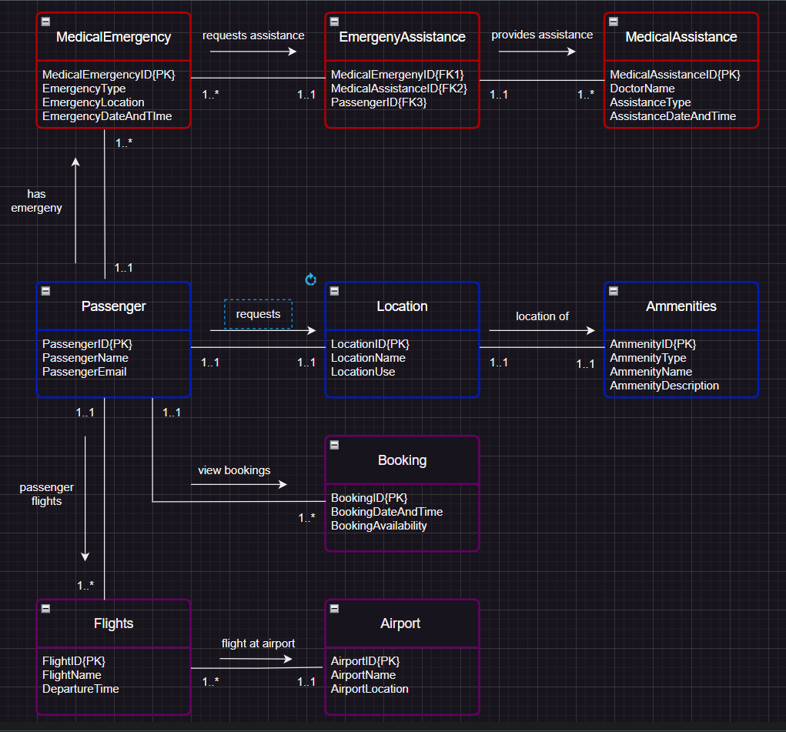

3.2

<https://www.figma.com/>

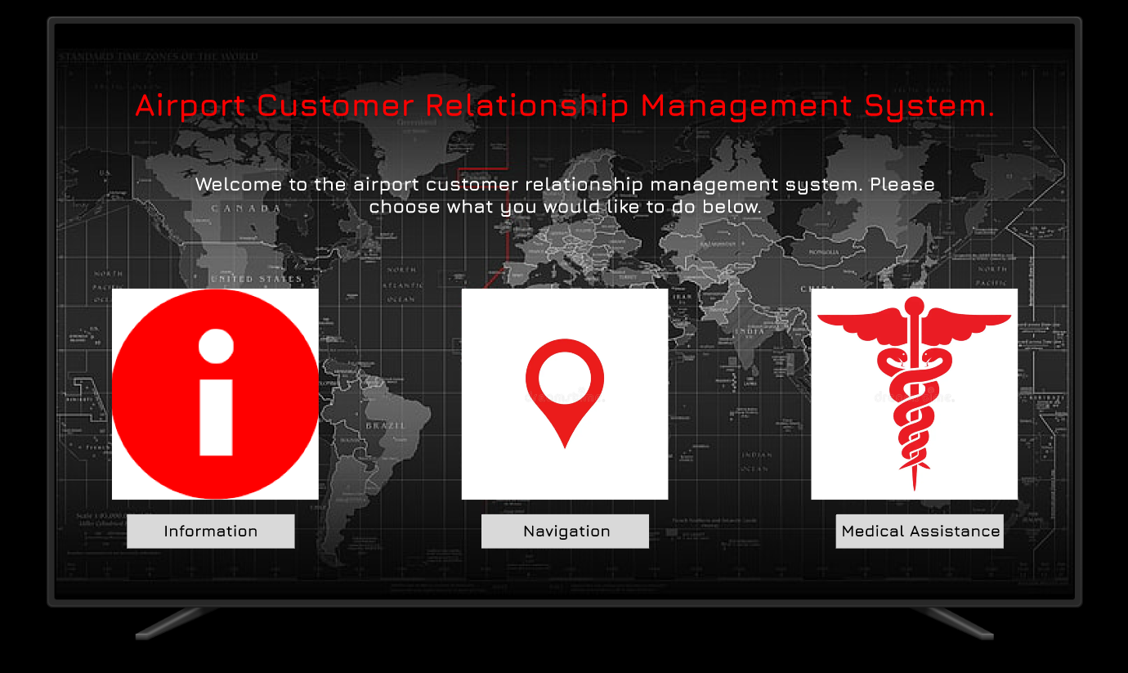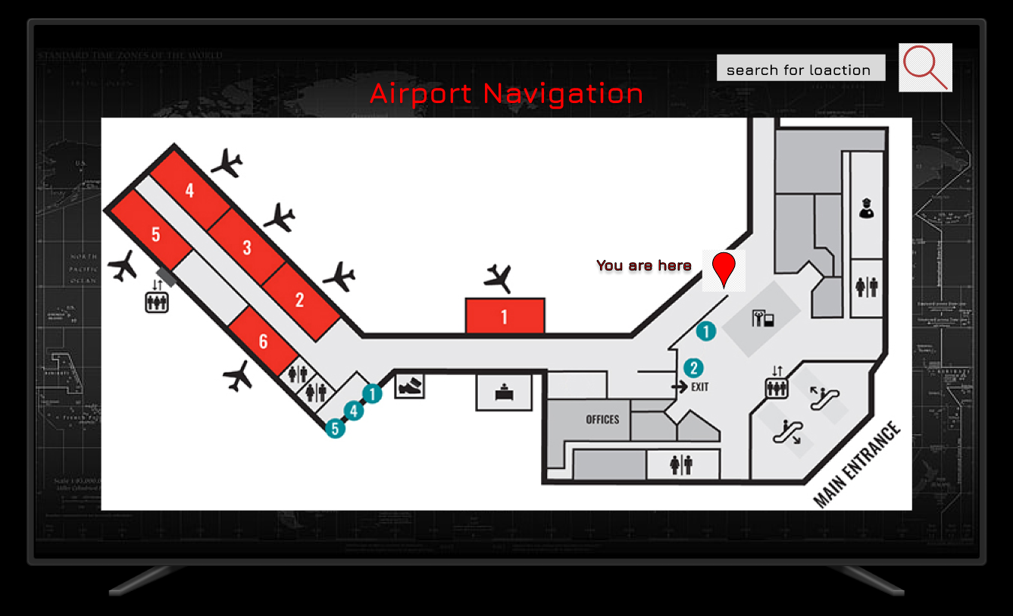

**Usability:** the application layout is simple and user-friendly with a description under each button which tells the user what the button does. There is also a pinpoint on the map which lets users know their exact location within the airport.

**Visibility:** The interface uses high contrast colours, big visible text, and strategically placed icons with a bright red to catch the user’s attention. There are also clear labels for each button.

**Affordance:** the interface makes use of affordances to guide the users through the application. the kiosk uses buttons and touch gestures such as scrolling and swiping to navigate through the system with ease.(UXpin, 2023)

Bibliography

**Articles**

(No date) *14 agile characteristics for project management success | indeed.com*. Available at: <https://www.indeed.com/career-advice/career-development/agile-characteristics> (Accessed: 10 May 2024).

Awati, R. (2023) *What is iterative development?: Definition from TechTarget*, *Software Quality*. Available at: <https://www.techtarget.com/searchsoftwarequality/definition/iterative-development> (Accessed: 10 May 2024).

Billah, R. (2024) *Beyond it: The expansive impact of agile on project management*, *LinkedIn*. Available at: <https://www.linkedin.com/pulse/beyond-expansive-impact-agile-project-management-rafsan-billah-0itnc/> (Accessed: 10 May 2024).

Brush, K. and Silverthorne, V. (2022) *What is Agile Software Development (agile methodologies)?*, *Software Quality*. Available at: <https://www.techtarget.com/searchsoftwarequality/definition/agile-software-development> (Accessed: 10 May 2024).

Fernando, J. (no date) *What are stakeholders: Definition, types, and examples*, *Investopedia*. Available at: <https://www.investopedia.com/terms/s/stakeholder.asp#:~:text=The%20primary%20stakeholders%20in%20a,%2C%20governments%2C%20and%20trade%20associations>. (Accessed: 10 May 2024).

Jameslopresti (2024) *Benefits of using Agile Project Management*, *Villanova University*. Available at: <https://www.villanovau.com/articles/project-management/the-use-of-agile-project-management-is-increasing/#:~:text=Benefits%20of%20Agile%20Methodology&text=Increased%20focus%20on%20the%20specific,Better%20control%20of%20projects> (Accessed: 10 May 2024).

Person (2023) *9 key benefits of using the agile methodology*, *Kissflow*. Available at: <https://kissflow.com/project/agile/benefits-of-agile/#:~:text=The%20benefits%20of%20Agile%20makes,within%20the%20given%20project%20constraints>. (Accessed: 10 May 2024).

Rachaelle Lynn                                                    Senior Marketing Manager                Rachaelle Lynn, Manager, S.M. and Lynn, R. (2020) *Benefits of agile*, *Planview*. Available at: <https://www.planview.com/resources/guide/agile-methodologies-a-beginners-guide/benefits-agile/> (Accessed: 10 May 2024).

Sharma, L. (2023) *10 nonfunctional requirements to consider in your enterprise architecture*, *Enable Architect*. Available at: <https://www.redhat.com/architect/nonfunctional-requirements-architecture> (Accessed: 10 May 2024).

UXPin (2023) *Affordances 101 – what you can learn about user interactions*, *Studio by UXPin*. Available at: <https://www.uxpin.com/studio/blog/affordances-user-interaction/#:~:text=In%20the%20context%20of%20UI,and%20push%20in%20real%20life>. (Accessed: 10 May 2024).

Yalovenko, A. (2023) *How to write a vision and scope document: Step-by-step guide with examples*, *Orangesoft*. Available at: <https://orangesoft.co/blog/how-to-write-a-vision-and-scope-document> (Accessed: 10 May 2024).

**Design tools**

<https://app.diagrams.net/>

<https://www.figma.com/>

**Image URL’s]**

<https://www.wallpaperflare.com/search?wallpaper=world+map>

<https://www.iconsdb.com/red-icons/info-icon.html>

<https://thumbs.dreamstime.com/b/red-map-pin-icon-flat-style-pointer-symbol-marker-sign-gps-position-navigation-button-vector-illustration-156002514.jpg>

<https://thumbs.dreamstime.com/b/red-medical-sign-13302453.jpg>

<https://www.mobileairportauthority.com/mra/maps-second-floor/>

<https://www.google.com/url?sa=i&url=https%3A%2F%2Fwww.clipartmax.com%2Fmiddle%2Fm2i8i8K9K9H7m2b1_google-map-red-pin%2F&psig=AOvVaw2b5H19WhJTi1V00BVa9A3u&ust=1715452447131000&source=images&cd=vfe&opi=89978449&ved=0CBIQjRxqFwoTCND9w7_cg4YDFQAAAAAdAAAAABAE>

<https://p1.hiclipart.com/preview/738/690/570/explore-icon-find-icon-magnifier-icon-png-clipart.jpg>